|  |  |  |  |
| --- | --- | --- | --- |
| **Briefing Report**  **Sydney South**  **Planning Panel** | | **Date:** | **6 June 2023** |
| **Item:** | **PPSSSH-110** |
| **Council:** | **Georges River Council** |
| **Address:** | 9 Gloucester Road, Hurstville  Lot 30 DP 785238 | | |
| **Development Application No:** | DA2022/0061 | | |
| **Proposal:** | Demolition of existing structures, and construction of an 6-18 storey mixed use development across 4 buildings containing 349 residential apartments, retail and office floor space above three (3) basement levels containing 459 parking spaces and tree removal. | | |
| **CIV:** | $174,522,815 (excluding GST) | | |
| **Exhibition:** | Notification: 17 March 2022 – 31 March 2022 | | |
| **Number of submissions:** | Notification 1: Three (3) submissions received including an anonymous submission. | | |
| **Council staff:** | Brendan Leo – Consultant Town Planner  Nicole Askew - Coordinator Development Assessment | | |
| **Architect:** | Turner | | |
| **Zoning:** | MU1 – Mixed Use – B4 at the time of lodgement | | |
| **Applicant:** | Aaron Sutherland | | |
| **Owners:** | GTB Hurstville Pty Ltd | | |

|  |
| --- |
| Aerial Photo   **Figure 1:** Aerial view of subjectsite outlined in blue (*Source: Intramaps 2023*) |

|  |
| --- |
| Proposed Site Plan   **Figure 2:** Proposed Site Plan (*Source: Turner, 2023*) |

# DEVELOPMENT DETAILS

The proposal seeks the demolition of existing structures, and construction of a development ranging in scale from 8 to 18 storey mixed use development containing commercial floor space, retail floor space, 349 apartments, above 3 basement levels and tree removal.

* Building A is 18 storeys and comprises a total of 131 apartments.
* Building B is 16 storeys and comprises a total of 81 apartments.
* Building C is 11 storeys and comprises a total of 58 apartments.
* Building D is 8 storeys and comprises a total of 50 apartments.
* Building E is 6 storeys and comprises a total of 29 apartments.

A detailed breakdown of the proposed works is provided below:

Basement Level 03 (RL 50.9)

* 178 Residential car spaces including 16 accessible spaces.
* 48 bicycle spaces.
* Fire Stairs and lift access.
* Carpark exhaust.
* Storage (131).

Basement Level 02 (RL 54.0)

* 143 Residential car spaces including 20 accessible spaces and a car wash bay.
* 27 Residential visitor’s car spaces.
* 46 bicycle spaces.
* Fire Stairs and lift access.
* Carpark exhaust.
* Storage (124).

Basement Level 01 (RL57.1)

* 107 car spaces comprising 65 commercial, 39 visitor and 3 car share car spaces
* 15 motorcycle and 44 bicycle spaces
* Building A – Commercial waste room
* Building A – Grease arrestor room
* Building A – Bulky waste room
* Building A – Garbage room
* Building B – Fan room
* Building B – Grease arrestor room
* Building B – Garbage room
* Building C – Commercial lift and lobby
* Building C – Garbage room
* Building C – Main switch room
* Building C – Fire pump room
* Building C – Carpark exhaust
* Building C – Mechanical room
* Building C – Cold water pump room.
* Building C – 2 x 5000L grease arrestors
* Building C – Firewater storage tank
* Building D – Garbage and Central Collection room.
* Building D – Main switch room
* Building D – 500L Grease arrestor
* Building D – Garbage room
* Building E – Cold water pump room
* Building E – Mechanical Plant room
* Building E – Bulky waste room
* Building E – Garbage room
* Rainwater Reuse Plant.
* Rainwater Reuse pump and filtration
* Rainwater reuse Tank
* Vehicular access from Gloucester Road
* Loading dock
* Fire Stairs and lift access
* Good delivery

Ground level

* Building D Residential apartments comprising the following:
  + 1 x 1 bedroom apartments.
  + 3 x 2 bedroom apartments.
* Building D Residential lobby, lift and fire stairs including fire indicator panel (FIP)
* Building E Residential apartments comprising the following:
  + 1 x 1 bedroom apartments.
  + 3 x 2 bedroom apartment.
* Building E Residential lobby, lift and fire stairs including fire indicator panel (FIP)
* Building A – Retail EOT/storage
* Building A – Male and Female changerooms and toilets
* Building A – Fire Stairs and lift access.
* Vehicular access from Gloucester Road.
* Building C – Commercial Lobby
* Building C – 4 x Retail premises
* Building C – Café
* Building C – Residential Lobby including fire indicator panel (FIP)
* Building C – Male and female amenities and accessible toilet
* Building C – Fire Stairs and lift access
* Substation with frontage to Gloucester Road

Level 01

* Building A Retail space
* Building A Residential Lobby including Fire indicator Panel (FIP)
* Building A and B Male and Female amenities including accessible toilet.
* Building B Retail space
* Building B Residential Lobby
* Building B Fire Control Room
* Building B Fire booster integrated into building
* Building C Commercial floor space – 2 tenancies
* Building C Male and female amenities including accessible toilet
* Building D Residential apartments comprising the following:
  + 3 x 1 bedroom apartments.
  + 5 x 2 bedroom apartments.
* Building E Residential apartments comprising the following:
  + 2 x 1 bedroom apartments.
  + 4 x 2 bedroom apartment.
  + 1 x 3 bedroom apartment.
* Fire Stairs and lift access.

Level 02

* Building A Residential apartments comprising the following:
  + 6 x 1 bedroom apartment.
  + 4 x 2 bedroom apartments.
  + 1 x 3 bedroom apartment
* Building B Residential apartments comprising the following:
  + 2 x 1 bedroom apartments.
  + 2 x 3 bedroom apartments.
* Building C Commercial floor space – 2 tenancies
* Building C Male and female amenities including accessible toilet
* Building D comprising the following:
  + 3 x 1 bedroom apartment.
  + 4 x 2 bedroom apartments.
* Building E Residential apartments comprising the following:
  + 4 x 2 bedroom apartments.
  + 1 x 3 bedroom apartments.
* Fire Stairs and lift access.

Level 03

* Building A Residential apartments comprising the following:
  + 6 x 1 bedroom apartment.
  + 4 x 2 bedroom apartments.
  + 1 x 3 bedroom apartments
* Building B Residential apartments comprising the following:
  + 2 x 1 bedroom apartments.
  + 2 x 3 bedroom apartments.
* Building C Residential apartments comprising the following:
  + 6 x 1 bedroom apartments.
  + 4 x 2 bedroom apartments.
  + 1 x 3 bedroom apartments.
* Building D Residential apartments comprising the following:
  + 3 x 1 bedroom apartment.
  + 4 x 2 bedroom apartments.
* Building E Residential apartments comprising the following:
  + 4 x 2 bedroom apartment.
  + 1 x 3 bedroom apartments.
* Fire Stairs and lift access.

Level 04

* Building A Residential apartments comprising the following:
  + 6 x 1 bedroom apartment.
  + 4 x 2 bedroom apartments.
  + 1 x 3 bedroom apartments
* Building B Residential apartments comprising the following:
  + 2 x 1 bedroom apartments.
  + 2 x 3 bedroom apartments.
* Building C Residential apartments comprising the following:
  + 3 x 1 bedroom apartments.
  + 4 x 2 bedroom apartments.
  + 1 x 3 bedroom apartments.
* Building D Residential apartments comprising the following:
  + 1 x 1 bedroom apartment.
  + 4 x 2 bedroom apartments.
  + 1 x 3 bedroom apartment.
* Building E Residential apartments comprising the following:
  + 4 x 2 storey 2 bedroom apartments (lower level).
  + 1 x 2 bedroom apartment
  + 2 x 2 storey 3 bedroom apartment (lower level).
* Fire Stairs and lift access.

Level 05

* Building A Residential apartments comprising the following:
  + 1 x 1 bedroom apartment.
  + 5 x 2 bedroom apartments.
  + 1 x 3 bedroom apartments
* Building B Residential apartments comprising the following:
  + 1 x 1 bedroom apartments.
  + 5 x 2 bedroom apartments
* Building C Residential apartments comprising the following:
  + 1 x 1 bedroom apartments.
  + 4 x 2 bedroom apartments.
  + 2 x 3 bedroom apartments.
* Building D Residential apartments comprising the following:
  + 1 x 1 bedroom apartment.
  + 4 x 2 bedroom apartments.
  + 1 x 3 bedroom apartment.
* Building E Residential apartments comprising the following:
  + 4 x 2 storey 2 bedroom apartments (upper level).
  + 1 x 2 bedroom apartment
  + 2 x 2 storey 3 bedroom apartment (upper level).
* Fire Stairs and lift access.

Level 06

* Building A Residential apartments comprising the following:
  + 1 x 1 bedroom apartment.
  + 5 x 2 bedroom apartments.
  + 1 x 3 bedroom apartments
* Building B Residential apartments comprising the following:
  + 1 x 1 bedroom apartments.
  + 5 x 2 bedroom apartments
* Building C Residential apartments comprising the following:
  + 1 x 1 bedroom apartment
  + 4 x 2 bedroom apartments.
  + 2 x 3 bedroom apartments.
* Building D Residential apartments comprising the following:
  + 4 x 2 bedroom apartments.
  + 2 x 3 bedroom apartment.
* Building E Roof top area comprising the following:
  + Lobby Area.
  + Communal open space area including seating.
  + Fire stairs
  + Lift over runs
  + Plant room
  + AC units

Level 07

* Building A Residential apartments comprising the following:
  + 1 x 1 bedroom apartment.
  + 5 x 2 bedroom apartments.
  + 1 x 3 bedroom apartments
* Building B Residential apartments comprising the following:
  + 1 x 1 bedroom apartment
  + 5 x 2 bedroom apartments
* Building C Residential apartments comprising the following:
  + 1 x 1 bedroom apartment
  + 4 x 2 bedroom apartments.
  + 2 x 3 bedroom apartments.
* Building D Residential apartments comprising the following:
  + 4 x 2 bedroom apartments.
  + 2 x 3 bedroom apartment.

Level 08

* Building A Residential apartments comprising the following:
  + 1 x 1 bedroom apartment.
  + 5 x 2 bedroom apartments.
  + 1 x 3 bedroom apartments
* Building B Residential apartments comprising the following:
  + 1 x 1 bedroom apartments.
  + 5 x 2 bedroom apartments
* Building C Residential apartments comprising the following:
  + 3 x 2 bedroom apartments.
  + 3 x 3 bedroom apartments.
* Building D Roof top area comprising the following:
  + Lobby Area.
  + Communal open space area including seating.
  + Fire stairs
  + Lift over runs
  + Plant room
  + AC units

Level 09

* Building A Residential apartments comprising the following:
  + 1 x 1 bedroom apartment.
  + 5 x 2 bedroom apartments.
  + 1 x 3 bedroom apartments
* Building B Residential apartments comprising the following:
  + 1 x 1 bedroom apartments.
  + 5 x 2 bedroom apartments
* Building C Residential apartments comprising the following:
  + 3 x 2 bedroom apartments.
  + 3 x 3 bedroom apartments.

Level 10

* Building A Residential apartments comprising the following:
  + 1 x 1 bedroom apartment.
  + 5 x 2 bedroom apartments.
  + 1 x 3 bedroom apartments
* Building B Residential apartments comprising the following:
  + 1 x 1 bedroom apartments.
  + 5 x 2 bedroom apartments
* Building C Residential apartments comprising the following:
  + 3 x 2 bedroom apartments.
  + 3 x 3 bedroom apartments.

Level 11

* Building A Residential apartments comprising the following:
  + 1 x 1 bedroom apartment.
  + 5 x 2 bedroom apartments.
  + 1 x 3 bedroom apartments
* Building B Residential apartments comprising the following:
  + 1 x 1 bedroom apartments.
  + 5 x 2 bedroom apartments
* Building C Roof top area comprising the following:
  + Lobby Area.
  + Communal open space area including seating.
  + Fire stairs
  + Lift over runs
  + Plant room
  + AC units

Level 12

* Building A Residential apartments comprising the following:
  + 1 x 1 bedroom apartment.
  + 5 x 2 bedroom apartments.
  + 1 x 3 bedroom apartments
* Building B Residential apartments comprising the following:
  + 1 x 1 bedroom apartments.
  + 5 x 2 bedroom apartments

Level 13

* Building A Residential apartments comprising the following:
  + 1 x 1 bedroom apartment.
  + 5 x 2 bedroom apartments.
  + 1 x 3 bedroom apartments
* Building B Residential apartments comprising the following:
  + 1 x 1 bedroom apartments.
  + 5 x 2 bedroom apartments

Level 14

* Building A Residential apartments comprising the following:
  + 1 x 1 bedroom apartment.
  + 5 x 2 bedroom apartments.
  + 1 x 3 bedroom apartments
* Building B Residential apartments comprising the following:
  + 3 x 2 bedroom apartments.
  + 2 x 3 bedroom apartments

Level 15

* Building A Residential apartments comprising the following:
  + 1 x 1 bedroom apartment.
  + 5 x 2 bedroom apartments.
  + 1 x 3 bedroom apartments
* Building B Residential apartments comprising the following:
  + 3 x 2 bedroom apartments.
  + 2 x 3 bedroom apartments

Level 16

* Building A Residential apartments comprising the following:
  + 1 x 1 bedroom apartment.
  + 5 x 2 bedroom apartments.
  + 1 x 3 bedroom apartments
* Building B Residential apartments comprising the following:
  + 3 x 2 bedroom apartments.
  + 2 x 3 bedroom apartments

Level 17

* Building A Residential apartments comprising the following:
  + 1 x 1 bedroom apartment.
  + 5 x 2 bedroom apartments.
  + 1 x 3 bedroom apartments
* Building B Roof top area comprising the following:
  + Lobby Area.
  + Communal open space area including seating.
  + Fire stairs
  + Lift over runs
  + Plant room
  + AC units

Level 18

* Building A Residential apartments comprising the following:
  + 1 x 1 bedroom apartment.
  + 5 x 2 bedroom apartments.
  + 1 x 3 bedroom apartments

Level 19

* Building A Roof top area comprising the following:
  + Lobby Area.
  + Communal open space area including seating.
  + Fire stairs
  + Lift over runs
  + Plant room
  + AC units

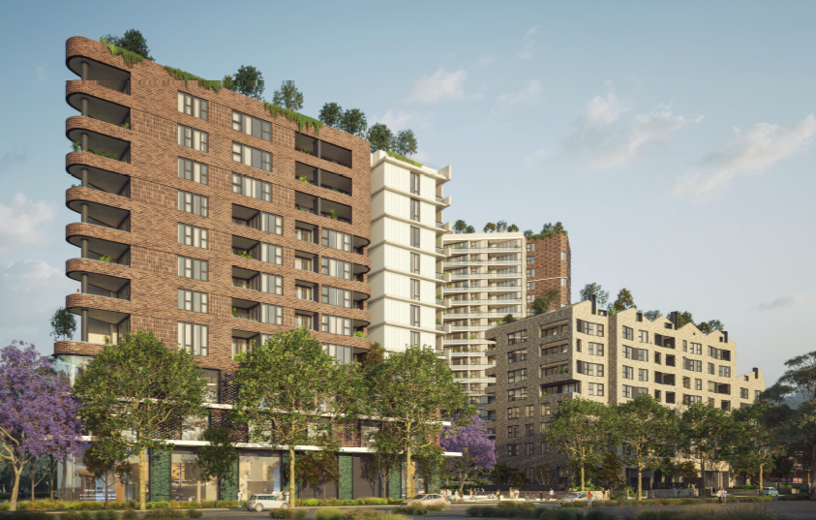

**Figure 3:** Perspective of proposal as viewed from Gloucester Road

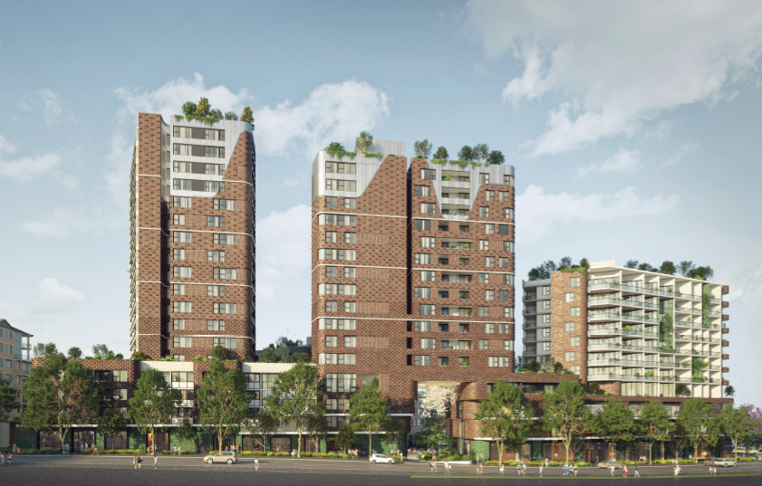

**Figure 4:** Perspective of proposal as viewed from Forest Road

# DEVELOPMENT SUMMARY

|  |  |
| --- | --- |
| **Element** | **Proposal** |
| Height | * Building A: 63.75 metres. * Building B: 59.05 metres. * Building C: 44.8 metres. * Building D: 32.97 metres. * Building E: 25.75 metres. |
| Levels | * Building A: 18 storeys. * Building B: 16 storeys. * Building C: 11 storeys. * Building D: 8 storeys. * Building E: 6 storeys. |
| Apartment mix | 349 residential apartments comprised as follows:   * 74 x 1 bedroom apartments (21%). * 218 x 2 bedroom apartments (63%). * 57 x 3 bedroom apartments (16%). |
| Commercial/Retail | 4620sqm of commercial/retail floor space as follows:  6 x retail premises.  4 x commercial premises.  1 x café. |
| Car parking spaces | 459 car parking spaces comprising the following:   * 320 Residential spaces (including 36 disabled spaces and a carwash bay). * 70 Residential visitors’ spaces. * 45 retail spaces. * 24 commercial spaces (including 3 disabled spaces). |
| Bicycle parking spaces | 136 bicycle spaces as follows:  Basement 01 – 42 bicycle spaces  Basement 02 – 46 bicycle spaces  Basement 03 – 48 bicycle spaces |
| Motorcycle spaces | 15 spaces provided on basement level 01 |
| Communal open space | 4788sqm (51.8%) |
| Deep soil Area | 687sqm (7.4%) |
| Solar access for apartments | 81% (79/106) - 2 hours between 9am -3pm |
| Cross ventilation for apartments | 66.8% |

The subject development site is known as Lot 30 DP 785238, No 9 Gloucester Road, Hurstville.

It is an irregular shaped allotment with a 148.7 metre frontage to Gloucester Road and a 158.3 metre frontage to Forest Road. The development site has a total area of 9,240sqm and has a cross fall of approximately 4 metres from the south-west corner to north-east corner of the development site.

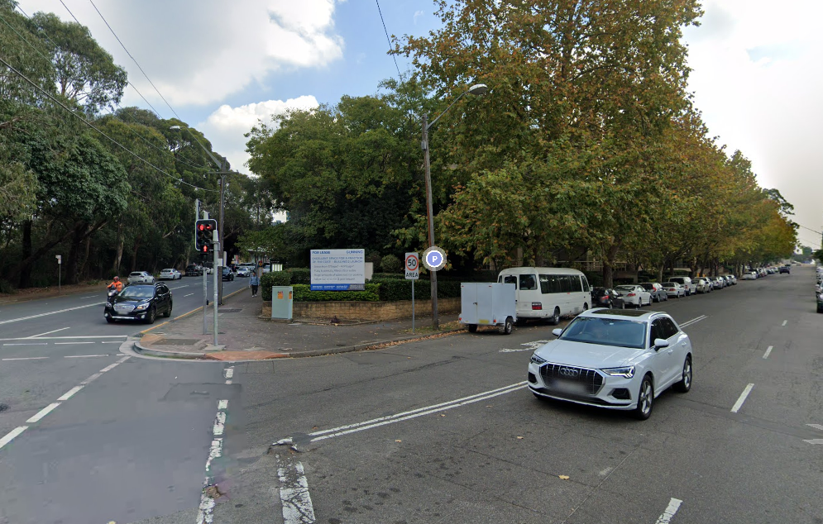

**Figure 5:** Subject site as viewed from the corner of Gloucester Road looking down Forest Road

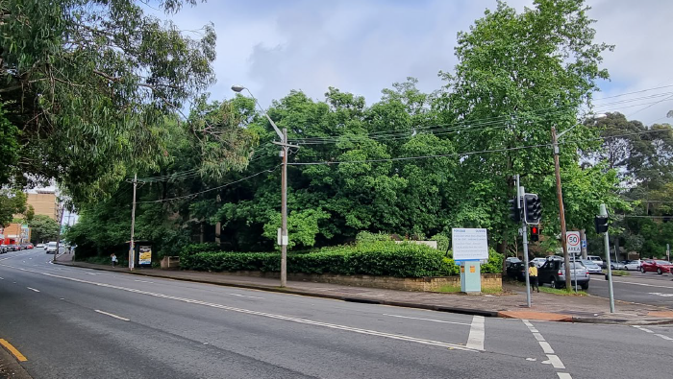

**Figure 6:** Subject site as viewed from the corner of Gloucester Road and Forest Road looking towards Forest Road

The site contains a number of street trees around the perimeter of the site. The Gloucester Road frontage contains a number of London Plane Trees that are required to be retained under any development of the site.

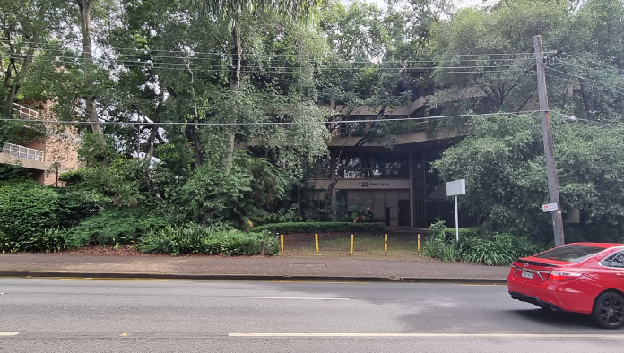

**Figure 7:** The Forest Road frontage of the subject development site.

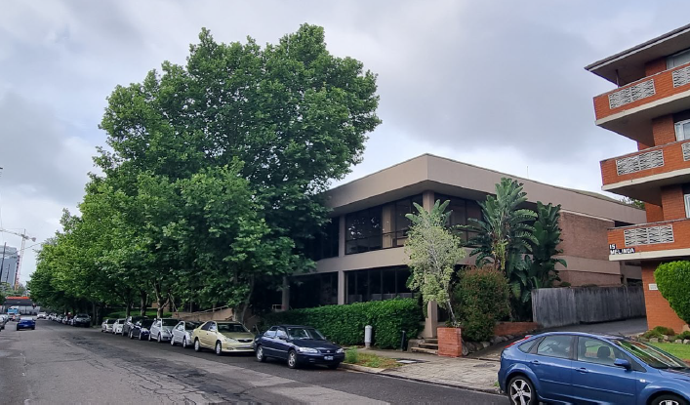

**Figure 8**: Gloucester Road looking east towards Forest Road

The site is currently occupied by three commercial buildings between two and four storeys in height in an ‘office park’ configuration of buildings. Vehicular access is provided from Gloucester Road and there is a through-site link from Forest Road to Gloucester Road.

The subject site is bounded by Gloucester Road to the east and Forest Road to the west. The site is located within the Hurstville City Centre and within 800m of Hurstville Railway Station.

# SURROUNDING DEVELOPMENT

The immediate area is mixture of different building types and uses. Along Forest Road are a number of multi storey buildings with smaller scale Residential Flat Buildings (RFB’s) located along Gloucester Road.

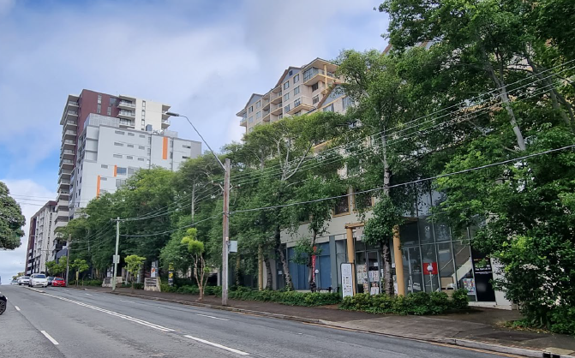

**Figure 9**: Development to the west along the Forest Road frontage.

Located along Gloucester Road. Immediately adjacent to the site to the west along Gloucester Road are residential flat buildings of varying scales and height.

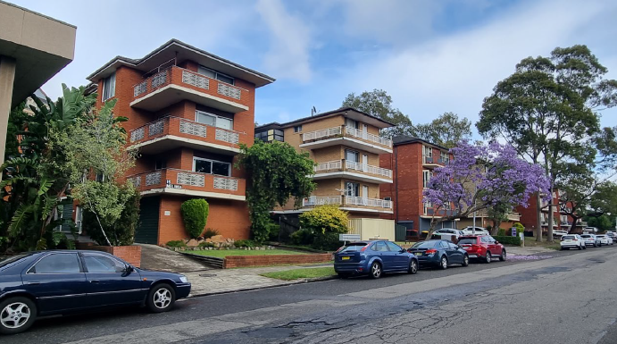

**Figure 10**: Existing buildings adjoining the site along Gloucester Road

To the east across Gloucester Road are residential flat buildings varying in heights from three (3) to four (4) storeys. Further to the east and located on the opposite corner of Gloucester Road and Forest Road, a service station with car park.

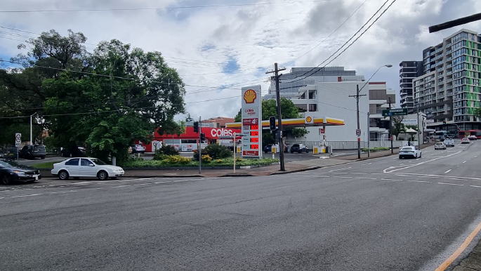

**Figure 11:** View to the west of the service station located opposite the subject site with Hurstville CBD in the background.

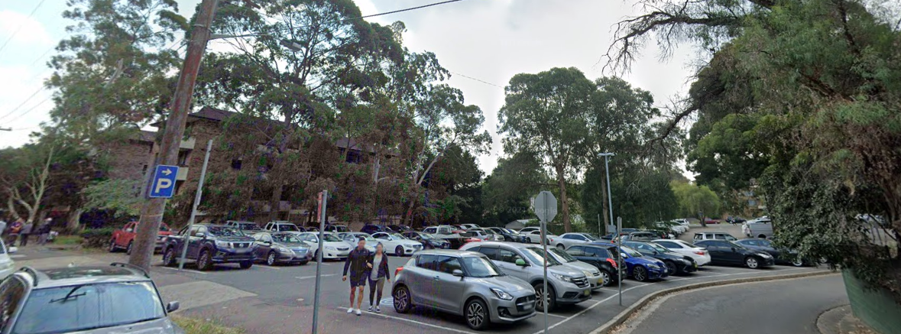

**Figure 12**: Car park located adjacent to the service station.

# BACKGROUND

# Background

* A Planning Proposal (PP2015/0005), seeking to amend the Hurstville Local Environmental Plan 2012 (HLEP 2012) to increase the FSR from 3:1 to 4:1 (including a minimum non-residential FSR of 0.5:1) and increase the maximum building height applying to the Site from 23m to a range of heights of 23m, 30m, 40m, 50m and 60m, was lodged with Council on 9 October 2015.
* At its meeting on 27 August 2018, Council resolved to endorse the Planning Proposal (PP2015/0005) to be forwarded to the Department of Planning and Environment for a Gateway Determination, seeking to amend FSR and Height controls of the Hurstville Local Environmental Plan 2012 (HLEP 2012) for the Site.
* A Gateway Determination to publicly exhibit the Planning Proposal was issued by the Department on 26 February 2019.
* At its meeting on 24 June 2019, Council resolved to endorse an amended Planning Proposal and supporting documentation, including the correct height range and extension of timing to complete the amendment to the LEP, to be forwarded to the Department of Planning and Environment for their endorsement and approval to publicly exhibit.
* The Planning Proposal and draft DCP were publicly exhibited in January and February 2020. The Planning Proposal sought to:

1. Increase height from 23m to a range of heights of 23m, 30m, 40m, 55m and 60m.
2. Increase FSR from 3:1 to 4:1 including a minimum non-residential FSR of 0.5:1.

* The Master Plan which is illustrated in Figure 18 below supports the Planning Proposal (PP2015/0005). The Master Plan comprises a mixed-use component (commercial and residential flat building) at the northern end of the Site with ground floor apartments and a shop top housing component at the southern end of the Site. The configuration of the Master Plan design comprises a perimeter block form of development with buildings ranging in height from 4 to 18 storeys as follows
* Building A – 4 to 18 storeys (60m)
* Building B – 4 to 16 storeys (55m)
* Building C – 12 storeys (40m)
* Building D – 8 storeys (30m)
* Building E – 4 to 6 storeys (23m)

Building D is located centrally along the Gloucester Road frontage of the Site and is an 8 storey residential flat building with a rooftop common open space. Building E is located along the north-western side of the Site and is a 6 storey residential flat building that is attached to Building D

* The concept scheme formed the basis of the Planning Proposal (PP2015/0005) including a residential flat building (Building D and E) at the northern end of the Site on Gloucester Road, as well as a 0.5:1 commercial component along the Forest Road frontage and also the corner of Forest Road and Gloucester Road. The Planning Proposal was also supported by a Voluntary Planning Agreement which requires the developer to pay a monetary contribution of $3,619,308 to the Council for the provision of public facilities in the Council’s area, including public infrastructure, amenities and services, public domain and public road infrastructure, and key traffic and road infrastructure in the Hurstville City Centre. The Voluntary Planning Agreement has been executed and the contribution paid to Council.
* On 25 May 2020, Council resolved to forward the Planning Proposal (PP2015/0005) to the Department of Planning, Industry and Environment for gazettal. On 12 February 2021, Amendment 18 to amend the Hurstville Local Environmental Plan 2012 (HLEP 2012) by increasing the FSR and the maximum building height for the Site was gazetted.
* Since the gazettal of the new controls for the Site, the Hurstville Local Environmental Plan 2012 has been replaced by the Georges River Local Environmental Plan 2021 (“GRLEP”). Whilst the new GRLEP maintains the same MU1 Mixed Use zone (B4 at the time of lodgement) for the Site, it has nonetheless made “residential flat development” a prohibited use. In addition, one of the objectives of Clause 6.13 Development in certain business zones, which applies to the MU1 Mixed Use zone (B4 at the time of lodgement), is ‘*to maintain existing, and encourage additional, non-residential uses along ground floor street frontages’.* As a result, a residential flat building (Building D and E) at the northern end of the Site on Gloucester Road is not permissible under the GRLEP.
* Planning Proposal (PP2021/7338) lodged in December 2021 seeking to amend Schedule 1 of the GRLEP 2021 to provide RFBs as an additional permitted use and also excluding the application of Clause 6.13 to part of the subject site which prevents ground floor residential apartments in the MU1 mixed use zone (B4 at the time of lodgement).
* DA2022/0061 lodged to Council on 24 February 2022 seeking development consent for the demolition of existing structures, and construction of a 6 to 18 storey mixed use development containing 4620sqm of commercial/retail floor space, 349 residential apartments, above three (3) basement levels containing 459 parking spaces and tree removal.
* Sydney South Planning Panel (SSPP) ‘Kick Off’ briefing undertaken on 22 March 2022.
* Planning Proposal (PP2021/7338) was considered and supported by the Local Planning Panel (LPP) on 2 June 2022.
* Gateway request sent to Department of Planning and Environment on 1 July 2022.
* Gateway determination provided by Department of Planning and Environment on 5 August 2022
* Sydney South Planning Panel (SSPP) second briefing undertaken on 23 August 2022.
* The Planning Proposal (PP2021/7338) was updated by the proponent to address the conditions of the Gateway Determination, prior to the commencement of the public exhibition on 31 August 2022.
* The Planning Proposal (PP2021/7338) and supporting documentation were placed on public exhibition for a period exceeding 28 days, from 31 August 2022 to 28 September 2022, during which a total of six (6) submissions were received from the community.
* Matters raised in the submissions were addressed in the Georges River Council Environment & Planning Committee report dated 10 October 2022.
* Council subsequently resolved (CCL094-22) at its meeting held 31 October 2022 that the Planning Proposal (PP2021/7338) be forwarded to the Department of Planning and Environment for gazettal.
* Planning Proposal (PP2021/7338) was gazette on 25 November 2022 and became Georges River LEP 2021 - Amendment No 5.

**ASSESSMENT MATTERS**

**State Environmental Planning Policies**

|  |  |
| --- | --- |
| **State Environmental Planning Policy** | **Complies** |
| State Environmental Planning Policy (Resilience and Hazards) 2021 | Yes |
| State Environmental Planning Policy (Biodiversity and Conservation) 2021 | Yes |
| State Environmental Planning Policy (Transport and Infrastructure) 2021 | Yes |
| State Environmental Planning Policy (Industry and Employment) 2021 | Yes |
| State Environmental Planning Policy No.65 – Design Quality of Residential Apartment Development. | Yes |
| State Environmental Planning Policy (Building Sustainability Index: BASIX) 2004 | Yes |
| State Environmental Planning Policy (Planning Systems) 2021 | Yes |

**State Environmental Planning Policy (Resilience and Hazards) 2021**

The Resilience and Hazards SEPP has replaced and repealed the following SEPPs:

* State Environmental Planning Policy (Coastal Management) 2018;
* State Environmental Planning Policy No 33—Hazardous and Offensive Development; and
* State Environmental Planning Policy No 55—Remediation of Land.

Chapter 4 Remediation of Land

Chapter 4 of the SEPP relating to remediation of land applies to the site.

Chapter 4 aims to promote the remediation of contaminated land in order to reduce the risk of harm to human health or any other aspect of the environment. Clause 4.6 requires contamination and remediation to be considered in determining a development application. The consent authority must not consent to the carrying out of development on land unless it has considered whether or not the land is contaminated.

The application is initially accompanied by a Preliminary Site Investigation (PSI) report prepared by Douglas Partners Pty Ltd. Conclusions of the PSI report stated that based on the information to date and in consideration of the site’s historical use, (residential and commercial) it is considered that the site has a low to medium risk of contamination. However, potential sources of contamination have been identified, therefore an intrusive investigation and a HBM survey should be undertaken to quantify and confirm the potential risk to receptors.

A Detailed Site Investigation report (DSI) and a Remedial Action Plan (RAP) were subsequently prepared by JKEnvironments. The findings of the DSI investigation are that following remediation and validation in accordance with the RAP, the site will be suitable for the proposed development.

## State Environmental Planning Policy (Biodiversity and Conservation) 2021

The Biodiversity and Conservation SEPP has replaced and repealed the following SEPPs:

* State Environmental Planning Policy (Vegetation in Non-Rural Areas) 2017;
* State Environmental Planning Policy (Koala Habitat Protection) 2020;
* State Environmental Planning Policy (Koala Habitat Protection) 2021;
* Murray Regional Environmental Plan No 2—Riverine Land;
* State Environmental Planning Policy No 19—Bushland in Urban Areas;
* State Environmental Planning Policy No 50—Canal Estate Development;
* State Environmental Planning Policy (Sydney Drinking Water Catchment) 2011;
* Sydney Regional Environmental Plan No 20—Hawkesbury-Nepean River (No 2—1997);
* Sydney Regional Environmental Plan (Sydney Harbour Catchment) 2005;
* Greater Metropolitan Regional Environmental Plan No 2—Georges River Catchment; and
* Willandra Lakes Regional Environmental Plan No 1—World Heritage Property.

### Chapter 2 Vegetation in non-rural areas

Chapter 2 of the SEPP relating to vegetation in non-rural areas applies to the site.

Chapter 2 regulates clearing of native vegetation on urban land and land zoned for environmental conservation/management that does not require development consent.

The Vegetation SEPP applies to clearing of:

1. Native vegetation above the Biodiversity Offset Scheme (BOS) threshold where a proponent will require an approval from the Native Vegetation Panel established under the Local Land Services Amendment Act 2016; and
2. Vegetation below the BOS threshold where a proponent will require a permit from Council if that vegetation is identified in the council’s development control plan (DCP).

The objectives of the Chapter are to protect the biodiversity values of trees and other vegetation in non-rural areas and preserve the amenity of non-rural areas through the preservation of trees and other vegetation. This policy is applicable pursuant to Clause 2.3 of the SEPP as the site is within both Georges River Council and the MU1 Mixed Use zone (B4 at the time of lodgement).

The proposal includes the removal of all site trees which has been assessed by Council’s Senior Landscape & Arboricultural Assessment Officer and has been supported along with the recommendation to retain the 11 street trees. Additional information has been requested including root mapping to ensure the retention of the street trees, a tree protection plan and amendments to the landscape plan to ensure adequate deep soil areas capable of supporting trees with mature height of approximately 15 metres.

### Chapter 11 Georges Rivers Catchment

Chapter 11 of the SEPP relating to the Georges Rivers Catchment applies to the site.

All stormwater from the proposed development can be treated in accordance with Council’s Water Management Policy and would satisfy the relevant provisions of Chapter 11. The application was reviewed by Councils Drainage Engineer who has raised no objection to the proposal subject to conditions.

## State Environmental Planning Policy (Transport and Infrastructure) 2021

The Transport and Infrastructure SEPP has replaced and repealed the following SEPPs:

* *State* Environmental *Planning Policy (Infrastructure) 2007;*
* *State Environmental Planning Policy (Educational Establishments and Child Care Facilities) 2017;*
* *State Environmental* Planning *Policy (Major Infrastructure Corridors) 2020; and*
* *State Environmental* Planning *Policy (Three Ports) 2013.*

### Chapter 2 Infrastructure

The application was referred to Ausgrid pursuant to clause 2.48 of the SEPP. Ausgrid found the proposal satisfactory subject to conditions being imposed.

Clause 2.98 – Excavation in, above, below or adjacent to rail corridors

Clause 2.98 states the following:

*(1) This section applies to development (other than development to which section 2.100 applies) that involves the penetration of ground to a depth of at least 2m below ground level (existing) on land—*

*(a) within, below or above a rail corridor, or*

*(b) within 25m (measured horizontally) of a rail corridor, or*

*(c) within 25m (measured horizontally) of the ground directly below a rail corridor, or*

*(d) within 25m (measured horizontally) of the ground directly above an underground rail corridor.*

The proposal received concurrence from Transport for NSW (Sydney Trains) subject to conditions of development consent being applied.

Clause 2.119 – Development with frontage to classified road

Clause 2.119 states the following:

*(2) The consent authority must not grant consent to development on land that has a frontage to a classified road unless it is satisfied that—*

1. *where practicable and safe, vehicular access to the land is provided by a road other than the classified road, and*
2. *the safety, efficiency and ongoing operation of the classified road will not be adversely affected by the development as a result of—* 
   1. *the design of the vehicular access to the land, or*
   2. *the emission of smoke or dust from the development, or*
   3. *the nature, volume or frequency of vehicles using the classified road to gain access to the land, and*
3. *the development is of a type that is not sensitive to traffic noise or vehicle emissions, or is appropriately located and designed, or includes measures, to ameliorate potential traffic noise or vehicle emissions within the site of the development arising from the adjacent classified road.*

The vehicular access to the site is only via Gloucester Road.

### Clause 2.120 - Impact of road noise or vibration on non-road development

Clause 2.119 of the SEPP relates to the impact of road noise or vibration on residential development, which is located on land adjacent to a road with an annual average daily traffic volume of more than 20,000 vehicles. An acoustic report has been prepared by Acoustic Logic which confirms that the Forest Road frontage and part of the Gloucester Road frontage are subject to higher noise levels such that the open window noise criteria cannot be met, as such the development relies on mechanical ventilation. The proposed development is able to comply with the road noise and vibration requirements of the SEPP subject to the recommendations of the acoustic report being implemented.

### Clause 2.121 - Traffic Generating development

Clause 2.121 of SEPP (Transport and Infrastructure) requires that before granting consent to a development with a car park of more than 50 which connects to a classified road within 90 metres, Councils must refer the application to the Roads and Maritime Services (Transport for NSW) for comment and must consider the accessibility of the site, including:

* The efficiency of movement of people to and from the site and the extent of multi-purpose trips, and
* The potential to minimise the need for travel by car and to maximise movement of freight in containers or bulk freight by rail, and
* Any potential traffic safety, road congestion or parking implications of the development.

The application is accompanied by a Traffic Impact Assessment Report prepared by Henson Consulting which addresses the relevant traffic issues associated with the proposal. The proposal has been referred to Transport for NSW (RMS) who have provided comments and conditions in for the application.

**State Environmental Planning Policy No.65 – Design Quality of Residential Apartment Development.**

SEPP 65 applies to development for the purpose of a new residential flat building, shop top housing or mixed use development, the substantial redevelopment/refurbishment of one of these buildings or the conversion of an existing building into one of these types of buildings provided the building is at least 3 or more storeys and the building contains at least 4 or more dwellings. The development meets the definition of a residential flat building. As such the provisions of SEPP 65 are applicable to the proposed development.

SEPP 65 aims to improve the design quality of residential flat developments, provide sustainable housing in social and environmental terms that is a long-term asset to the community and delivers better built form outcomes.

In order to satisfy these aims and improve the design quality of residential apartment buildings in the State, the plan sets design principles in relation to context and neighbourhood character, built form and scale, density, sustainability, landscape, amenity, safety, housing diversity and social interaction, and aesthetics.

The proposed development has been assessed against the relevant provisions of SEPP 65 and the Apartment Design Code. The proposal generally satisfies the controls and objectives and the non-compliances and concerns that have been identified are discussed later in the report under the urban design section.

**State Environmental Planning Policy (Building Sustainability Index: BASIX) 2004**

State Environmental Planning Policy (Building Sustainability Index: BASIX) 2004 applies to the development and aims to encourage sustainable residential development. A BASIX certificate has been submitted with the application. The proposal complies with the minimum requirements.

**State Environmental Planning Policy (Planning Systems) 2021**

The Planning Systems SEPP has replaced and repealed the following SEPPs:

* State Environmental Planning Policy (State and Regional Development) 2011;
* State Environmental Planning Policy (Aboriginal Land) 2019; and
* State Environmental Planning Policy (Concurrences and Consents) 2018.

Part 2.4 Regionally significant development

The proposal is a regionally significant pursuant to Clause 2 of Schedule 6 of State Environmental Planning Policy (Planning Systems) 2021 as it has a CIV of more than $30 million in accordance with the SEPP.

In this case the Sydney South Planning Panel is the consent authority for the subject development application.

**State Environmental Planning Policy (Industry and Employment) 2021**

The application is not seeking uses and resultant advertising signage.

## Georges River Local Environmental Plan 2021 (GRLEP 2021)

The site is zoned MU1 Mixed Use (B4 at the time of lodgement) under the GRLEP 2021 as shown in Figure 13 below.

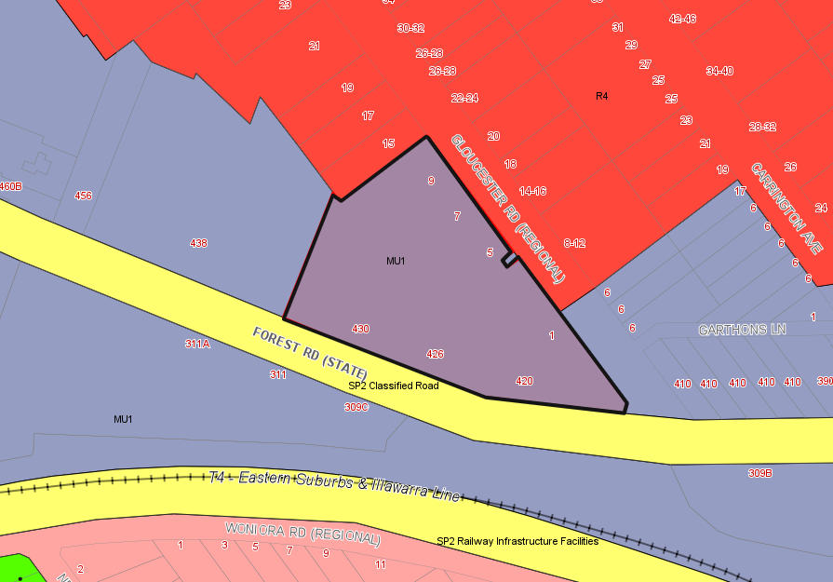

**Figure 13**: Zoning Map (GRLEP 2021) – site outlined in black

An assessment of the proposal against the LEP standards is provided below.

|  |  |  |  |  |
| --- | --- | --- | --- | --- |
| **Clause** | **Standard** | **Proposal** | | **Complies** |
| **Part 2: Permitted or Prohibited Development** | | | | |
| 2.2 Zoning of Land to which Plan applies | MU1 Mixed Use | The proposed application is for residential flat building, mixed use development and retail and commercial premises which are all permitted land uses in the MU1 Mixed Use zone under GRLEP 2021.  (Residential flat buildings are permitted by Schedule 1 Additional Permitted Uses – 14 and the provisions of Clause 6.13(5A) apply to the site). | | Yes |
| 2.3 Zone objectives and Land use table | Objectives of zone to be satisfied | The proposal satisfies the objectives of the zone by providing a mixture of residential apartments, retail premises and commercial premises which are consistent with the zone objectives and are suitable for the site and will not adversely impact neighbouring properties. | | Yes |
| 2.7 Demolition | Demolition requires development consent. | Consent for demolition of existing structures is sought. | | Yes |
| **Part 4: Principal Development Standards** | | | | |
| 4.3 Height of Buildings | Maximum permitted height as per height of building map:  Building A: 60m  Building B: 55m  Building C: 40m  Building D: 30m  Building E: 23m | Building A: 63.75m  Building B: 59.05m  Building C: 44.8m  Building D: 32.97m  Building E: 25.75m | | No, see clause 4.6 submitted |
| **Figure 14**: Maximum heights of buildings within subect site bordered in black. | | | | |
| **Note:** Clause 4.6 objection has been submitted requesting a variation to the development standards for the maximum building height has been submitted. | | | | |
| 4.4 Floor Space Ratio | Maximum permitted  4:1 | 3.97:1 (36,702sqm) | | Yes |
| 4.4B Exceptions to floor space ratio – non residential uses | The objective of this clause is to encourage an appropriate mix of residential and non-residential uses in order to ensure a suitable level of non-residential floor space is provided to promote employment and reflect the hierarchy of the business zones. | Development consent must not be granted for development on the following land identified on the [Floor Space Ratio Map](https://www.planningportal.nsw.gov.au/publications/environmental-planning-instruments/georges-river-local-environmental-plan-2021) unless the non-residential floor space ratio is—   1. for land identified as “Area 3”—at least 0.5:1,   The non residential floor space is 4,620sqm which equates to 0.5:1. | | Yes |
| 4.5 Calculations of Floor space and Site area | Floor space to be calculated in accordance with Clause. | Floor space calculated in accordance with clause. | | Yes |
| 4.6 Exceptions to Development Standards | A Clause 4.6 variation request has been submitted in relation to the proposed building heights. | | | |
| **Part 5: Miscellaneous Provisions** | | | | |
| 5.10 Heritage Conservation | (1) **Objectives** The objectives of this clause are as follows—  (a) to conserve the environmental heritage of the Georges River local government area,  (b) to conserve the heritage significance of heritage items and heritage conservation areas, including associated fabric, settings and views,  (c) to conserve archaeological sites,  (d) to conserve Aboriginal objects and Aboriginal places of heritage significance. | | The site is not a heritage item and is not within a heritage conservation area. | Yes |
| **Part 6: Additional Local Provisions** | | | | |
| 6.1 Acid Sulfate Soils (ASS) | (1) The objective of this clause is to ensure that development does not disturb, expose or drain acid sulfate soils and cause environmental damage. | | The site is not identified as being affected by acid sulfate soils. | Yes |
| 6.2 Earthworks | (2) Development consent is required for earthworks unless—  (a) the earthworks are exempt development under this Plan or another applicable environmental planning instrument, or  (b) the earthworks are ancillary to development that is permitted without consent under this Plan or to development for which development consent has been given. | | The proposal includes the provision of three (3) levels of basement car parking.  This is a standard amount of excavation and site works to accommodate a development of this scale and density.  The proposed earthworks are not considered to be unreasonable for the uses sort. | Yes |
| 6.3 Stormwater Management | (2) In deciding whether to grant development consent for development, the consent authority must be satisfied that the development—  (a) is designed to maximise the use of water permeable surfaces on the land having regard to the soil characteristics affecting on-site infiltration of water, and  (b) includes, if practicable, on-site stormwater detention or retention to minimise stormwater runoff volumes and reduce the development’s reliance on mains water, groundwater or river water, and  (c) avoids significant adverse impacts of stormwater runoff on adjoining properties, native bushland, receiving waters and the downstream stormwater system or, if the impact cannot be reasonably avoided, minimises and mitigates the impact, and  (d) is designed to minimise the impact on public drainage systems. | | Stormwater drainage has been reviewed by Councils Drainage Engineer and is considered acceptable subject to conditions. | Yes |
| 6.7 Airspace Operations | (2) Development consent must not be granted to development to which this clause applies unless—  (a) the consent authority has consulted the relevant Commonwealth body, and  (b) the relevant Commonwealth body advises the consent authority that—  (i) the development will penetrate the Limitations or Operations Surface but it does not object to the development, or  (ii) the development will not penetrate the Limitations or Operations Surface. | | The application has been reviewed by the relevant authorities. The height of the prescribed airspace at this location is 134 metres AHD. Approval has been granted permitting a maximum height of RL 128 metres AHD. The maximum height annotated on any building in the development is Building A at RL128.00. | Yes |
| 6.9 Essential Services | Development consent must not be granted to development unless the consent authority is satisfied that any of the following services that are essential for the development are available or that adequate arrangements have been made to make them available when required—  (a) the supply of water,  (b) the supply of electricity,  (c) the supply of telecommunications facilities,  (d) the disposal and management of sewage,  (e) stormwater drainage or on-site conservation,  (f) suitable vehicular access. | | Water and electricity supply is available to the site.  Telecommunications are available.  Sewage available to the site.  Proposed stormwater disposal is satisfactory subject to conditions.  The site intends to provide vehicular access from Gloucester Road in accordance with the requirements of the DCP. | Yes |
| 6.10 Design Excellence | (1) The objective of this clause is to deliver the highest standard of sustainable architecture and urban design. | | Noted. | Yes |
| 6.10 (3) (b) | (3) (b) land in the following zones if the building concerned is 3 or more storeys or has a height of 12 metres or greater above ground level (existing), or both, not including levels below ground level (existing) or levels that are less than 1.2 metres above ground level (existing) that provide for car parking—  (i) Zone R4 High Density Residential,  (ii) Zone E1 Local Centre,  (iii) Zone E2 Commercial Centre,  (iv) Zone E4 General Industrial,  (v) Zone MU1 Mixed Use. | | The proposal is for a building within the MU1 Mixed Use zoning (B4 at the time of lodgement), is greater than 3 storeys with a height greater than 12 metres.  The heights of this site have been established via a planning proposal. | Yes |
| 6.10 (4) | (4) Development consent must not be granted for development to which this clause applies unless the consent authority considers that the development exhibits design excellence. | | Council’s Urban Designer has raised some matters still to be resolved. | No |
| 6.10 (5) | (5) In considering whether the development exhibits design excellence, the consent authority must have regard to the following matters—  (a) whether a high standard of architectural design, materials and detailing appropriate to the building type and location will be achieved,  (b) whether the form and external appearance of the development will improve the quality and amenity of the public domain,  (c) whether the development detrimentally impacts on view corridors,  (d) how the development addresses the following matters—  (i) the suitability of the land for development,  (ii) existing and proposed uses and use mix,  (iii) heritage issues and streetscape constraints,  (iv) the relationship of the development with other development (existing or proposed) on the same site or on neighbouring sites in terms of separation, setbacks, amenity and urban form,  (v) bulk, massing and modulation of buildings,  (vi) street frontage heights,  (vii) environmental impacts such as sustainable design, overshadowing and solar access, visual and acoustic privacy, noise, wind and reflectivity,  (viii) pedestrian, cycle, vehicular and service access and circulation requirements, including the permeability of pedestrian networks,  (ix) the impact on, and proposed improvements to, the public domain,  (x) achieving appropriate interfaces at ground level between the building and the public domain,  (xi) excellence and integration of landscape design,  (xii) the provision of communal spaces and meeting places,  (xiii) the provision of public art in the public domain,  (xiv) the provision of on-site integrated waste and recycling infrastructure,  (xv) the promotion of safety through the application of the principles of crime prevention through environmental design. | | Council’s Urban Designer has raised some matters still to be resolved. | No |
| **6.11** Environmental sustainability | (1) The objective of this clause is to ensure that the development to which this clause applies is consistent with principles of best practice environmentally sensitive design. | | Noted. | Yes |
| **6.11 (2)** | (2) This clause applies to development—  (a) on land in the following zones—  (i) Zone R4 High Density Residential,  (ii) Zone E1 Local Centre,  (iii) Zone E2 Commercial Centre,  (iv) Zone E4 General Industrial,  (vi) Zone MU1 Mixed Use.  (b) that involves—  (i) the erection of a new building, or  (ii) the change of use of an existing building, or  (iii) alterations or additions to an existing building that, in the opinion of the consent authority, are significant. | | The proposed development being new buildings and as the subject site is zoned MU1 Mixed Use (B4 at the time of lodgement) this clause applies to this development. | Yes |
| **6.11 (3)** | (3) Development consent must not be granted to development on land to which this clause applies if the building is 1,500 square metres in gross floor area or greater unless adequate consideration has been given to the following in the design of the building—  (a) water demand reduction, including water efficiency, water recycling and minimisation of potable water usage,  (b) energy demand reduction, including energy generation, use of renewable energy and reduced reliance on mains power,  (c) indoor environmental quality, including daylight provision, glare control, cross ventilation and thermal comfort,  (d) the minimisation of surfaces that absorb and retain heat and the use of surfaces that reflect heat where possible,  (e) a reduction in new materials consumption and use of sustainable materials, including recycled content in concrete, sustainable timber and PVC minimisation,  (f) transport initiatives to reduce car dependence such as providing cycle facilities, car share and small vehicle parking spaces. | | The subject building exceeds 1500sqm so this clause applies to the development.  The applicant has indicated that the proposed development satisfies the criteria of the clause. | Yes |
| **6.13** Development in certain business zones | (1) The objectives of this clause are as follows—  (a) to promote uses that attract pedestrian traffic along ground floor street frontages,  (b) to maintain existing, and encourage additional, non-residential uses along ground floor street frontages,  (c) to strengthen the viability of existing established centres,  (d) to maintain opportunities for business and retail development that is suited to high exposure locations. | | Noted. | Yes |
| **6.13 (2)** | (2) This clause applies to land in the following zones—  (a) Zone E1 Local Centre,  (b) Zone MU1 Mixed Use. | | The subject site is zoned MU1 Mixed Use (B4 at the time of lodgement) and as such the clause applies. | Yes |
| **6.13 (3)** | (3) Development consent must not be granted for development on land to which this clause applies unless the consent authority is satisfied the development will not cause a part of the ground floor of a building that is facing a street to be used for the purposes of residential accommodation or tourist and visitor accommodation. | | The development proposes residential apartments at the ground level for buildings D and E. | No, see discussion below 6.13(5A) |
| **6.13 (4)** | (4) Subclause (3) does not apply to a part of a building that is used for the following purposes—  (a) entrances and lobbies, including as part of a mixed use development,  (b) access for fire services,  (c) essential services. | | Noted. | Noted |
| **6.13(5)** | Development consent must not be granted for the erection of a building with a gross floor area on the ground floor of more than 500m2 on land identified as “Area A” on the Land Zoning Map unless the consent authority is satisfied at least 500m2 of the gross floor area on the ground floor will be used for—  (a) a purpose other than residential accommodation or tourist and visitor accommodation, and  (b) a purpose specified in subclause (4). | | Buildings A, B and C comply, Buildings D and E excluded by 6.13(5A). | Yes |
| **6.13(5A)** | (5A) This clause does not apply to part of Lot 30, DP 785238, 9 Gloucester Road, Hurstville, identified as “Area A” on the Additional Permitted Uses Map. | | Exemption relates to the subject site. | Yes |

## Hurstville Development Control Plan No 2 (HDCP)

The proposed development is subject to the provisions of Hurstville Development Control Plan No 2. The Hurstville Development Control Plan No 2 applies to all land identified as Hurstville City Centre. The following table outlines the relevant controls of compliance with HDCP.

**Section 4.3 – City Centre West Precinct – Hurstville City Centre**

Section 4 of HDCP No 2 provides objectives and controls for the Hurstville City Centre Precincts.

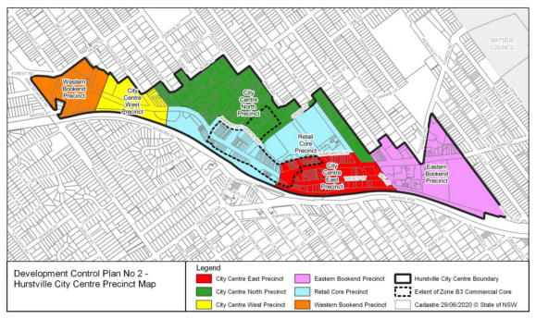

**Figure 15: Hurstville City Centre Precincts**

Section 5 of HDCP No 2 provides controls for residential, commercial and mixed use development in the Hurstville City Centre. The most relevant criterion is reproduced below:

|  |  |  |  |  |
| --- | --- | --- | --- | --- |
| **Clause** | | **Standard** | **Proposal** | **Complies** |
| **5.3.1 Site amalgamation** | | | | |
| Site amalgamation | * Floor plate 900-1000sqm * Street frontage 30m min | | The floor plate exceeds 1000sqm and the street frontage exceeds 30m. | Yes |
| |  | | --- | | **5.3.3 Floor Space Ratio** | | Proposal satisfies floor space ratio requirements in GRLEP 2021 | | | | | |
| **5.3.4 Building Height** | | | | |
| Proposal satisfies exceeds maximum building heights in GRLEP – 4.6 Variation requested submitted. | | | | |
| **5.3.5 Street setbacks** | | | | |
| Refer to the site specific requirements for 9 Gloucester Road, Hurstville under Section 8.3.9 of the DCP. | | | | |
| **5.4.1 Housing Choice, Affordability and mix** | | | | |
| 1. Variety of units | Developments comprising residential uses must provide a variety of residential units mix, sizes, and layouts within each development. The following criteria must be satisfied:   * Bed-sitter apartments and one bedroom apartments must not be greater than 25% and not less than 10% of the total mix of apartments within each development. * Two bedroom apartments are not to be more than 75% of the total mix of apartments within each development. * Three bedroom apartments are not to be less than 10% of the total mix of apartments within each development * Adaptable apartments not less than 10% | | 74 x 1 bedroom apartments (21  218 x 2 bedroom apartments (63%).  57 x 3 bedroom apartments (16%).  35 x adaptable apartments (10%). | Yes |
| **5.4.3 Sustainable Transport** | | | | |
| **5.4.3.3 Bicycle Facilities** | | | | |
| 1. Bicycle | Bicycle storage racks must be provided to accommodate a minimum of:  - 1 bicycle space for every 200 square metres of office floor space  - 1 bicycle space per 300 square metres of retail  - 1 bicycle space for every 3 residential units  Retails 2201/300 = 8 spaces  Office 2419/200 = 13 spaces  349/3 = 117 spaces  138 spaces required | | Bicycle spaces provided  Basement 3 - 48  Basement 2 - 46  Basement 1 - 42  Total spaces = 130 | No |
| 1. Bicycle rack location | Bicycle racks must be easily accessible from the public domain, and within areas that are well lit with adequate levels of natural surveillance. | | Bicycle racks within the basement with suitable lighting. | Yes |
| **5.4.4 Parking and Service Delivery Requirements** | | | | |
| **5.4.4.1 Vehicle Parking Rates** | | | | |
| 1. Parking areas | Parking areas must be designed to facilitate the safe and efficient movement and circulation of vehicles and pedestrians, including safe pedestrian access within car parks | | Additional information required. | No |
| 1. Loading areas | Parking areas and loading/unloading facilities must be designed to comply with the requirements of the latest Australian Standards for standard vehicles as defined by AS 2890 | | Additional information required. | No |
| 1. Car Park Location | Car park location and design needs to be carefully considered to ensure pedestrian safety, clear sight lines and to maintain streetscape character and amenity. All carparking must be positioned below ground level as demonstrated in Figure 5.4.1 below. Should site constraints restrict parking below ground level, parking must be concealed behind retail development, as demonstrated in Figure 5.4.2 | | Three (3) levels of basement parking proposed. | Yes |
| 1. Visitor parking | Provide on-site car parking, including visitor parking at the minimum rates stated in the car parking table below | | Residential parking rates are subject to the provisions of the RTA Guide to Traffic Generating Development due to the provisions of SEPP 65 |  |
| The proposed development is required to provide the following parking for retail and office premises:   * Retail 2201sqm – requires 45 spaces. * Commercial /Office – requires 25 spaces.   The proposal provides 45 retail spaces and 24 commercial office spaces. Based on the current floor pace proposed an additional space will need to be assigned to the commercial/office premises. | | | | |
| 1. Calculating car parking | Where parking calculations produce a fraction, the number is rounded up e.g. 3.2 spaces = 4 spaces | | Noted | Yes |
| 1. Allocation of car parking | For mixed use development the allocation of car spaces among the uses is to be indicated on the DA plans | | Parking spaces have been coloured showing the different uses. | Yes |
| 1. RMS | Development generating high amounts of traffic, as defined under State Environmental Planning Policy (Infrastructure) 2007, is to be referred to the Roads and Maritime Services (RMS) for consideration. Schedule 3 of SEPP (Infrastructure) 2007 outlines the provisions of developments that need to be referred to the RMS | | The application was referred to the RMS who is satisfied with the amended information and provided relevant comment and conditions. | Yes |
| **5.4.3.2 Other Parking Controls** | | | | |
| 1. Car wash bay | For residential developments containing 4 or more dwellings, a car wash bay is to be provided within the visitor parking area. The car wash bay may comprise a visitor car space | | One (1) car wash bay has been provided within the basement level 2. | Yes |
| **5.4.5 Vehicular Access and Manoeuvring** | | | | |
| **Location of Vehicular Access** | | | | |
| (c) Restriction on vehicle access point | Vehicular access to sites along Forest Road, (the First Order street) are not permitted. | | Vehicular access is from Gloucester Road. | Yes |
| (e) One vehicle access point | One vehicle access point only (including the access for service vehicles and parking for non residential uses within mixed use developments) will be permitted per site. More than one vehicular access point may be permitted on larger sites where it can be demonstrated to meet the above objectives. | | Only one vehicular access point is provided from Gloucester Road. | Yes |
| **Design of Vehicular Access** | | | | |
| (a) Vehicle entries | Vehicle entries must have high quality finishes to walls and ceilings as well as high standard detailing. No service ducts or pipes must be visible from the street. | | Generally acceptable finishes and no pipes are visible. | Yes |
| (d) Enter/Exit site | All vehicles must be able to enter and leave the site in a forward direction | | Vehicles can enter/exit in a forward direction. | Yes |
| (e) Pedestrian and vehicle access | Separate and clearly differentiated pedestrian and vehicle access must be provided | | Separate and clearly differentiated pedestrian and vehicle access provided. | Yes |
| (f) Location of vehicle access | Vehicular access must be located a minimum of 3 metres from pedestrian entrances. | | At least 3m of separation between pedestrian and vehicular entrances. | Yes |
| (k) Access ways to underground parking | Access ways to underground parking should not be located adjacent to doors or windows of the habitable rooms of any residential development | | Accessway located adjacent to the lobbies for Building D and E. | Yes |
| **5.4.6 Loading/Unloading facilities and Service Vehicle Manoeuvring** | | | | |
| (a) Compliance with AS2890 | For the development of all new buildings, site design must allocate adequate space for the loading, unloading, parking and manoeuvring of delivery and service vehicles within the subject property. Design of these areas shall comply with AS 2890 or as amended | | Additional details required to demonstrate compliant turning manoeuvring. | No |
| (b) Loading and Unloading activities | All loading and unloading activities must take place wholly within the loading bay, at all times. No loading or unloading activity is to take place within any car parking area, landscaping area, pedestrian footway or any public road reserve | | Additional details required to demonstrate compliant turning manoeuvring. | No |
| (c) Delivery vehicles | All delivery vehicles must be able to enter and leave the site in a forward direction | | Additional details required to demonstrate compliant turning manoeuvring. | No |
| **5.4.7 Pedestrian Access and Mobility** | | | | |
| (a) Paths of travel | Access to public areas of buildings and dwellings must follow the principles of universal access, with any development providing continuous paths of travel from all public roads and spaces as well as unimpeded internal access | | Generally acceptable. | Yes |
| (d) | The design of facilities (including car parking requirements) for disabled persons must comply with the relevant Australian Standard (AS 1428 Pt 1 and 2, or as amended) and the Disability Discrimination Act 1992 (as amended) | | Access report provided indicating compliance can be achieved. | Yes |

Section 6 provides controls in relation to site planning considerations. Some of these controls are reproduced below:

|  |  |  |  |
| --- | --- | --- | --- |
| **Clause** | **Standard** | **Proposal** | **Complies** |
| **6.1 Public Domain** | | | |
| 6.1.1 Landscaping (street trees) | Street tree planting | The 11 existing street trees are required to be retained as part of this development. Additional information including root mapping is required to confirm their retention as a result of the works. | To be conditioned. |
| 6.1. 2 Infrastructure | Street furniture, lighting | This will be subject to public domain plans required to be approved by Council’s Assets and Infrastructure Section. | To be conditioned. |
| 6.1.4 Paving, culture and Public Art | Paving for footpaths as per DCP. | This will be subject to public domain plans required to be approved by Council’s Assets and Infrastructure Section. | To be conditioned. |
| 6.1.4 (e) Public art | The design of public art to be in accordance with the Hurstville City Centre Public Domain Plan. | Public Art Strategy in accordance with Council Policy. | Yes |
| **6.2 Environmental Management** | | | |
| 6.2.1 Energy Efficiency and Conservation | Energy efficiency measures to be provided. | A valid BASIX certificate has been submitted with the application. | Yes |
| 6.2.2 Water Management | Water efficient measures to be provided. | A valid BASIX certificate has been submitted with the application. | Yes |
| 6.2.3 Stormwater Management | Suitable stormwater management plan is to be provided | The stormwater plan has been reviewed by Council’s engineer and has been found to be satisfactory subject to conditions. | Yes |
| 6.2.4 Waste Minimisation and Management | Waste Management requirements | Amendments required to the proposed waste management system. | No. Councils Waste Coordinator requires additional information and amendments to be made. |
| 6.2.5 Wind mitigation | A wind effects report has been submitted. | Wind Report submitted and found to be generally acceptable. | Yes |
| 6.2.6 Reflectivity | Minimise the impacts of reflected light and solar reflectivity from buildings on pedestrians and motorists. | The building is capable of compliance and the proposed materials will ensure reflectivity is minimised. | Yes |
| 6.2.7 Soil Management | Ensure changes to land use will not increase risk to public health. Suitable assessment should be undertaken to ascertain whether site is contaminated. | DSI and RAP submitted. | Yes |
| **6.4 Preservation of Trees and Vegetation** | | | |
| 6.4.3 Tree and Vegetation Management Process | Tree Management of subject site. | The development will result in the removal of a number of on-site trees, however the 11 street trees are proposed to be retained as part of the development. Root mapping is necessary and yet to be undertaken. | Yes |

**Section 8.3 - Gloucester Road, Hurstville**

Section 8.3 provides specific planning controls for the 9 Gloucester Road, Hurstville site. The following table summarises the proposal against the relevant controls:

|  |  |  |  |  |
| --- | --- | --- | --- | --- |
| **Clause** | | **Standard** | **Proposal** | **Complies** |
| **8.3.1 General Information** | | | | |
| **8.3.1.4 Urban Design Principles** | | | | |
| 1. Sustainable precinct. | Create a sustainable and livable environment for people through leadership and integration of design excellence. | | The proposal generally achieves these principles. | Yes |
| 1. Visual impact of building. | Development is distinctive, visually interesting and appealing. | | The Urban Designer has made suggested additional amendments. | No |
| 1. Context of the area | Development is designed to address the context of the area. | | The development is generally consistent with the planning proposal. | Yes |
| 1. SEPP 65 and ADG | Provision of good residential amenity in terms of privacy and built form by complying with the SEPP 65 Apartment Design Guide and incorporating appropriate transition between the new development and the adjoining residential development. | | Generally okay revised design addresses earlier concerns raised. | Yes |
| 1. Transition between sites | Development to ensure the built form outcome provides a transition to the adjoining sites | | The Urban Designer has made suggested additional amendments. | No |
| 1. Street edge | Clearly define the street edge with building podiums | | Generally acceptable. | Yes |
| 1. Façade articulation | Articulate the building façades to enhance the streetscape character | | The Urban Designer has requested changes. | No |
| 1. Human scale at street level | Maintain a human scale at the street level, with particular emphasis on the human experience in the built environment | | The proposal achieves an active street edge along Forest Road, with a human scale provided by virtue of the retail tenancies and the podium along the majority of the street frontage. | Yes |
| 1. Pedestrians connections | Provide pedestrian connections between streets and communal spaces | | Appropriate pedestrian connections have been identified. | Yes |
| 1. Tree retention | Retain significant existing trees and plant new trees to maintain the landscaped character of the Site. | | The street trees along Gloucester Road are required to be retained. | Yes |
| 1. Car Parking | Provide adequate basement car parking and a safe and efficient access network for both pedestrians and vehicles | | Generally acceptable. | Yes |
| 1. Streetscape | Create an active streetscape that enhances the liveliness and vitality of Forest Road | | Generally acceptable. | Yes |
| **8.3.2 Background and Context** | | | | |
| **8.3.2.1 Urban Context** | | | | |
| Range of flexible commercial floorspace | The new development needs to provide a range of flexible commercial floor space, contribute to the public domain and maintain the amenity of adjoining residential land uses | | The proposal provides retail and commercial premises with flexibility on the design. | Yes |
| **8.3.2.2 Concept Master Plan** | | | | |
| Master plan requirements | A Concept Master Plan was prepared for the Site as part of the assessment of the Planning Proposal which amended HLEP 2012 and provides general guidance on the overall form of development on the Site. The concept master plan requires the following key features:   * a central communal open space * a through site link between Forest and Gloucester Roads * retention of significant trees in accordance with Section 8.3.3.8 * active street frontages with commercial uses occupying the ground floor along Forest Road and comprising a minimum FSR of 0.5:1. | | The plans provided indicate that the proposal generally adheres to the master plan. | Yes |
| **8.3.3 Development Requirements** | | | | |
| **8.3.3.1 Surveyors Certificate** | | | | |
| 1. Surveyors certificate | A Development Application for the site must be accompanied by a Surveyor’s Certificate including gross floor area diagrams to scale of each and every proposed level that indicates the breakup of residential and non-residential floor area, with a minimum non-residential floor space of 0.5:1; for the purpose of calculating gross floor area  Note: This is to be accompanied by a properly scaled surveyor diagram | | Still to be provided but break up of uses appears to be acceptable in architectural gross floor area plans. | No |
| **8.3.3.2 Commercial Floor Space** | | | | |
| 1. Retail and community uses | Retail and community uses shall be provided on the whole of the ground floor | | Retail and commercial uses are provided on the ground level in Buildings A, B and C. Ground level of Buildings D and E are permitted to be residential under Clause 6.13(5A) of GRLEP 2021. | Yes. |
| 1. Flexible types of office spaces | Flexible types of office spaces shall be provided above ground floor, including a range of floor plate sizes | | Level 01 in Buildings A and B and levels 01 and 02 in Building C provide commercial floor space above the ground floor level, in addition to providing commercial/retail space at ground level. | Yes |
| **8.3.3.3 Built Form and Setbacks** | | | | |
| 1. Setbacks | Development shall display a built form comprising a 4m front setback for the entire length of Forest Road to allow the provision of awnings and street tree planting (Refer #1 in Figure 3). | | A 4m setback has been provided to the Forest Road frontage. | Yes |
| 1. Street edge | Define the street edge by retaining significant trees along Forest and Gloucester Roads (Refer Section 8.3.3.8) | | Existing significant trees are proposed to be retained. | Yes |
| 1. Built form and setbacks | Development shall display a built form comprising a 2m front setback along the southern portion of Gloucester Road and 5m front setback along the remaining Gloucester Road frontage reflecting the established setback of the adjacent 4 storey residential flat buildings (Refer #2 and #3 in Figure 3) | | Provided. | Yes |
| 1. Setback for landscaping | Development shall display a 6m setback to side boundary at street level to allow for landscaping of the side boundary interface zone (Refer #4 in Figure 3). | | Provided. | Yes. |
| 1. Transition to adjoining buildings | An additional setback of minimum 3m is required for built forms above 4 storeys to allow suitable building separation and appropriate transition to adjoining developments (Refer #4 in Figure 3) | | Provided. | Yes |
| 1. Forest Road street edge | Define the Forest Road street edge by providing a podium of maximum 4 storeys, with the exception of Building C and a portion of Building B (unless where indicated in Figure 2) | | A four (4) storey podium has been provided to Forest Road. | Yes |
| 1. SEPP 65 and ADG | Building layout, setbacks and separation of building forms are to be in accordance with SEPP 65 and the ADG to ensure the amenity of residents is maintained.  Note: Refer to Figure 5.3.3: Indicative Building Floor to Ceiling heights in Section 5.3 Built Form Controls of this DCP. | | See comments under Urban Design and the SEPP 65 assessment. | Yes |
| 1. Insulation | All residential apartments are to be insulated and to have Impact Isolation between floors to achieve an Acoustical Star Rating of 5 in accordance with the standards prescribed by the Association of Australian Acoustical Consultants (AAAC). An Acoustic Report is to be submitted with the Development Application to ensure that the above standards have been achieved | | An acoustic report has been submitted with the application which indicates compliance can be achieved. | Yes |
| 1. Wind Impact Report | A Pedestrian Wind Impact Report prepared by a suitably qualified engineer is to be submitted with Development Applications for buildings 30m or higher, and for other buildings at the discretion of Council. At a minimum, the report is to:   1. report the likely impacts of wind on the pedestrian environment at the footpath level within the site and the public domain; and 2. show how the proposal minimises the impact of wind on the public and private domain. | | A Pedestrian Wind Impact Report prepared by a suitably qualified engineer has been provided which addresses wind impacts associated with the proposal. | Yes |
| **8.3.3.4 Façade Treatment and Street Corners** | | | | |
| 1. Building facades | Building facades must be articulated and employ materials and finishes that enhance and complement the streetscape character. | | See the Urban Design comments for details. | Can comply |
| 1. Street corners | The Forest and Gloucester Road street corner must be reinforced through strong architectural form that reflects the geometry of the site with appropriate use of materials, colour, height and transition towards Forest Road | | See the Urban Design comments for details. | Can comply |
| 1. Human scale at street level | Human scale at street level must be created through the use of fine-grain elements, rhythm, high quality materials and/or landscaping | | See the Urban Design comments for details. | Can comply |
| 1. Blank walls | The use of blank walls is not acceptable for façades visible from the public domain. Façade treatments such as wall cladding and green walls should be considered as alternatives to blank walls. | | See the Urban Design comments for details. | Can comply |
| 1. Modulation and articulation | Development must not rely solely on the use of two-dimensional colour and materials to create visual interest. Modulation and articulation in the building form must be explored | | See the Urban Design comments for details. | Can comply |
| 1. Essential services | Essential services such as substations and fire hydrants must be integrated into the design of the façade. | | The substation location to be reconsidered. | No |
| 1. Glazing balustrades | Clear glazing balustrades must be avoided where they are visible from the public domain | | Balustrades are generally acceptable. | Yes |
| 1. Level access | The ground floor along the prominent corner and extending up both Forest and Gloucester Roads must have (as close as possible) level access to the footpath and pedestrian access ways without any proposed basement carpark extending above such levels | | Forest Road provides street level access. | Yes |
| **8.3.3.5 Pedestrian Access and the Public Domain** | | | | |
| 1. Accessible routes | Provide high quality accessible routes to public and semi-public areas of the building and the site, including major entries, lobbies, communal open space, site facilities, parking areas and pedestrian pathways | | Generally acceptable. | Yes |
| 1. Public and private accessways | Separate and clearly distinguish between public and private pedestrian accessways and vehicle accessways and utilise consistent paving treatments throughout the site | | Generally acceptable. | Yes |
| 1. Illumination of site links | All pedestrian links are to have appropriate levels of illumination | | Can be conditioned to address this criterion. | Yes |
| 1. Through site link | The through-site link from Forest Road to the landscaped communal open space and Gloucester Road (Refer Figure 6) is to:  a. be a minimum of four storeys in height with no blank walls facing the underpass space.  b. ensure that a clear and safe path that is unobstructed by parking and services is available for pedestrians at all times. DCP No. 2 Hurstville City Centre (Amendment No. 12) – Effective 12 May 2021 Section 8, Page 14  c. incorporate elements that positively contribute to the Forest Road streetscape, especially from the public domain.  d. integrate landscaping elements such as existing and new tree plantings.  e. ensure pedestrian safety through the application of CPTED principles, especially measures that promote passive surveillance. | | The proposal provides a site through link in accordance with the indicative location shown in Figure 6 of the HDCP. | Yes |
| 1. Landscaped communal open space | The landscaped communal open space on the ground level is to provide the opportunity to be used in a variety of ways over different times of the day, week and year. | | Generally acceptable subject to further detailing. | Yes |
| 1. Electricity and telecommunications cables | The existing above ground electricity and telecommunication cables within the road reserve and within the site area are to be replaced, at the applicant’s expense, by underground cables and appropriate street light standards, in accordance with the Energy and Communication Provider’s guidelines | | Can be conditioned to satisfy this criterion. | Yes |
| **8.3.3.6 Active Street Frontages** | | | | |
| 1. Active street frontages | Active street frontages are to be provided along Forest Road in accordance with the HLEP 2012 Active Street Frontage Map (the “ASF Map”) | | The proposal provides an active street frontage to Forest Road comprising residential lobbies and retail tenancies at the ground floor of each building. | Yes |
| 1. Active street frontages | Active street frontages are to contribute to the liveliness and vitality of streets by:   * maximising entries and display windows to commercial premises or other uses that provide pedestrian interest and interaction; * providing a high standard of finish and appropriate level of architectural detail for shopfronts; and * providing elements of visual interest (minimising blank walls), such as display cases, or creative use of materials where fire escapes, service doors, equipment hatches and other services are provided. | | Active frontages are consistent with these requirements. | Yes |
| 1. Transparent glazing | Generally, a minimum of 70% of the ground floor frontage is to be transparent glazing with a predominantly unobstructed view from the adjacent footpath to at least a depth of 6m within the building. | | Appears compliant. | Yes |
| 1. Active frontage level with footpath | Active frontages are to be designed with the ground floor level at the same level as the footpath | | Active frontages on Forest Road for Buildings A, B and C are designed to provide direct access. | Yes |
| 1. Continuous awning | A continuous awning must be provided above all active street frontages. | | Located along the Forest Road frontage continuing around Building C with frontage to Gloucester Road. Not proposed for the RFB’s (Building D and E). | Yes |
| 1. Security grilles | Security grilles may only be fitted internally behind the shopfront and are to be fully retractable and at least 50% transparent when closed | | None proposed as part of this development. | Yes |
| **8.3.3.7 Open Space and Landscaping** | | | | |
| 1. Landscape communal open space | A landscaped communal open space is to be provided generally in the location shown in Figure 8 and is to include:  • A ground level communal open space of approximately 1,870sqm that is protected from the busier Forest Road environment and receives reasonable solar access;  • Retention of trees and proposed street tree planting in accordance with Section 8.3.3.7. | | The proposal provides 2060sqm of communal open space.  The proposal retains existing significant street trees and includes new street tree planting as required. | Yes  Yes |
| 1. Landscape Design | Landscape design is to be in scale with the development and should relate to building form; facilitate storm water infiltration through the use of permeable surfaces; and be easily maintained | | Additional information required. | No |
| 1. Landscaping | Landscaping is to ensure amenity of private and publicly accessible open spaces and solar efficiency of apartments by providing shade from the sun and shelter from the wind, including the use of deciduous trees for shading of windows and open space areas in summer and allowing solar access in winter | | Additional information required. | No |
| 1. Deep soil planting | Deep soil planting is to be provided in accordance with the ADG and incorporated in the landscaped central common area – the deep soil area should not be above the basement parking.  a. 6m wide deep soil landscaped screening along the interface with residential properties to the west (Refer Figure 8);  b. 6m wide deep soil planting along Gloucester Road (Refer Figure 8). | | See comments later in the report. | No |
| 1. Equitable access in communal open spaces | Additional communal open spaces such as above podium and internal courtyards may be provided to ensure equitable access to all residents | | Roof top communal open space provided for each building. | Yes |
| 1. Communal open space | All Development Applications are to include a landscaping plan for all landscaped areas prepared by a qualified landscape designer. The landscaping plan should demonstrate that there is no conflict with the location of services on the site and any deep soil planting area | | Root mapping required for street trees to ensure they can be retained and there is no conflict with services, cut for the basement levels and works in public domain. | No |
| **8.3.3.8 Tree Retention** | | | | |
| 1. Trees to be retained | Any new development must retain identified trees in accordance with Figure 9 and Table 1 in this section. | | The proposal indicates that these trees will be retained. | Yes |
| 1. New Trees required | Any new development must propose new trees in the locations identified in Figure 9. Details of the proposed trees, including the species and size, will need to be provided with the Development Application to the satisfaction of Council. The proposed tree canopy must exceed the existing canopy cover on the site of 3,385sqm. The costs of the works are to be borne by the applicant | | Councils Landscape Officer requires additional information. | No |
| 1. Trees on public land | Any trees that are located on public land will be subject to the payment of security in accordance with Council’s Tree Management Policy | | Street trees required to be retained. | Yes |
| **8.3.3.9 On-site Parking** | | | | |
| 1. Underground parking | Car parking must be located underground in a basement and be designed in accordance with Section 5.4 Transport, Traffic, Parking and Access of this DCP. | | Car parking is located underground in basement levels 01 to 03. | Yes |
| 1. Car parking rates | Car parking rates must comply with RMS car parking rates in accordance with the Apartment Design Guide. | | The car parking provided exceeds the minimum RMS car parking rates. | Yes |
| 1. Loading and unloading | All loading and unloading of goods is to be accommodated within the property and off the public roads, including garbage pickup | | All loading and unloading is proposed to be within the property. Basement level 01 has a nominated loading dock. | Yes |
| 1. Vehicles entering and exiting | All vehicles are to enter and exit in a forward direction. | | All vehicles can enter and exit in a forward direction. | Yes |
| 1. AS/NZS 2890.1 and AS 2890.6 compliance | The designs for all the levels of the basement car park are to adhere to the latest edition of relevant AS/NZS 2890.1, 2890.2 and 2890.6. | | Councils Traffic Engineer has identified some issues with the basement parking and additional information is required to demonstrate compliance. | No |
| 1. Safe and secure access | Safe and secure access is to be provided for building users, direct access to residential apartments and convenient access to customers /staff of the commercial uses | | Provided. | Yes |
| 1. Ventilation grilles | Ventilation grilles or screening devices of car park openings are to be integrated into the overall façade and landscape design of the development and must not be located above existing or proposed footpath levels along Forest Road and Gloucester Road. | | None proposed. | Yes |
| **8.3.3.10 Vehicle Access** | | | | |
| 1. Vehicular access | Vehicular access to the site is to be provided in accordance with Section 5.4 Transport, Traffic, Parking and Access of this DCP | | Satisfactory location identified. | Yes |
| 1. Vehicle access | Vehicle access to the site is to be located off Gloucester Road | | Vehicle access is off Gloucester Road only. | Yes |
| 1. Service vehicle access to the development | The appearance of car parking and service vehicle entries are to be improved by screening and locating garbage collection, loading/unloading and servicing areas within the basement of the development. Refer to Section 6.2.2 Waste Minimisation and Management of this DCP | | Generally acceptable but can be reinforced through conditions to meet this criterion. | Yes with conditions. |
| 1. Landscape buffer for vehicle access | Vehicle access to the site is to be setback from the neighbouring residential properties to provide for a landscaping buffer as shown in Figure 10 | | The proposed development provides access in accordance with the DCP. | Yes |

# KEY ISSUES

**Building Height**

The development site is subject to five height zones for the site with 23, 30, 40, 55 and 60 metres across the site.

The proposed developments seeks to vary the building height development standards for all buildings. The variations relate to screening, shade structures, architectural roof features, fire stairs and lift over runs. The variations to the top of the lift over run for each building is as follows:

* Building A – 6.25%
* Building B – 7.3%
* Building C – 12%
* Building D – 9.9%
* Building E – 11.95%

The applicant has submitted a Clause 4.6 request in support for the above variations.

**Urban Design**

The subject site is located within the Hurstville City Centre. The application was referred to Council’s Senior Specialist Planner (Urban Design) for comment in respect to the amended design and its compliance with State Environmental Planning Policy 65 (SEPP 65) principles and the provisions of the Apartment Design Guide (ADG). A number of issues previously raised remain unresolved resulting in a diminished urban design outcome that fails to adequately respond to the existing and emerging site context and setting. Outstanding issues are referenced below:

### Topography

Some of the new proposed ground floor FFL better respond to the topography in the vicinity of the corner of Forest and Gloucester Roads, however the FFL in the elevations have not been amended to match the floor plan levels. There is a 1.5m difference in the ground floor FFL for Building A and B along Forest Road that is not translated on the elevations. Accurate elevations and sections through the whole development should be provided with existing context and existing natural ground levels to ascertain the relationship of the built form, the public/private domain interface and the façade treatment.

### Street Activation

For the proposal to be consistent with the desired future character for the City Centre, which requires developments to provide high quality public domain that will contribute to the streetscape character, provide active streetscape/vibrancy, promote appropriate visual and physical connection at ground level, it is recommended that the proposal be amended as follows:

* Retail at the corner of Forest Road and Gloucester Road should address the

level changes within the building and the FFL along Gloucester Road should

be at footpath level.

* Retail along Forest Road and Gloucester Road should have direct access from

the street and not just from the pedestrian link.

* Relocating the substation that will result in an increase in the retail space to

enhance activation should be considered. Locating the substation adjacent the

driveway and consolidating the services in proximity of the north-western

boundary should be considered.

### Pedestrian Access (Residential Building Entry)

The proposal should be amended for the residential building entries and lobbies to

comply with the ADG. According to the ADG, building access areas such as lift lobbies, stairwells and hallways should be clearly visible from the public domain. In addition, as per the CPTED, a building entrances are required to be functional, accessible, pleasant pedestrian environments and safe. The residential building entries and lobbies should have maximum exposure to the street and designed without any obstructions.

Building lobbies should be designed to provide opportunity for casual social interaction preferably with access to natural light and ventilation.

There should be a direct physical and visual connection between the street and the

building. Building entrances should be well integrated into the overall building façade

and make positive contribution to the streetscape and enhance the presence of the

building on the streetscape and should be an effective wayfinding tool. Services should be relocated away from building lobbies. Building B has a “L-shaped” lobby with restricted width which is considered unsafe and lacks opportunities for social interaction. Building D has two lobbies that could be consolidated into a wider more function space in a more considered design.

Residential building entries along both roads remain largely unidentifiable and do not enhance the presence of the building in the streetscape resulting in poor wayfinding.

*Setbacks*

The design should be amended to incorporate a minimum 9m setback to the north-west boundary adjacent R4 Zone and a minimum 6m setback to the northwest boundary adjacent B4 Zone for the proposal to comply with the setback requirements and be consistent with the built form and setback objectives under the HDCP and ADG. In addition, plans with detail dimensions should be provided.

*Street wall Height and Upper Level Setback*

The proposed design should be amended as follows:

* Building E – the setback to the northwest boundary for built form above 4 storey

should be 9m.

* Building D – the built form above 4 storeys along Gloucester Road should be

setback by minimum 3m to address the surrounding residential context, enhance

the streetscape and be consistent with the objectives for built form and setbacks.

*Building Separation*

The design should be amended to comply with building separation distances prescribed in the ADG. This will not only enhance amenity by providing opportunity for sky views, enhance solar access, reduce building bulk and scale but also provide building separation that will contribute to the urban form and character of the area. The proposal is not supported given the significant departure form the required building separation.

*Building Bulk and Scale*

The design should be amended, and building breaks introduced to break up the

Building bulk and scale. This will provide opportunity for direct sunlight access to the COS and break down the building bulk and scale.

*Communal Open Space*

Building breaks should be incorporated in the “C” shaped built form to allow for direct sunlight access to the ground level COS to make it desirable, useable, and compliant with the HDCP requirements for sunlight access.

*Deep Soil Planting*

Given the site area, context and the scale of the development, it is recommended that the proposal should be amended to include a minimum 15% of the site as deep soil area as per the ADG recommendation for the proposal to enhance residential amenity, promote management of water, air quality and urban heat island effect as well transition to the lower density area to the west and north.

*Architectural Expression*

It is recommended that the architectural expression of the elevations and overall built

form be amended to enhance the streetscape especially given the corner location, scale of development and design excellence required under the GRLEP 2021.

The design should also incorporate thoughtful composition, lightweight materials and detailing to minimise the perceived bulk and scale. Recessing and projecting massing and elements to break down the mass and avoid flat monotonous facades should be considered. Appropriate building separation incorporated to enhance sky views and provide relief from the built form.

Every scale from a range of viewing distances, the building facades should appear rich in detail with the number and composition of elements and a balanced contrasting relationships between them when viewed from near and far. The proposal should present as an integrated design. Some of the architectural detailing or materials should either be extended beyond the podium or vice versa to present and integrated design.

The residential entries should be clearly identifiable and distinguishable from

commercial and private entries. Change in texture, material, architectural detail and

landscaping should be incorporate to distinguish building entries and enhance

streetscape.

One of Council’s priorities under the LSPS is to improve architectural quality of

developments. Hence, innovation is required in the design. Design solutions that

integrate vertical gardens in the building façades must be explored to enhance visual

appeal and address sustainability.

In conclusion, the proposal whilst an improvement on the earlier design is still not supported and will require considerable design amendments for it to be supported from an urban design perspective.

## Public Art

In considering whether a development exhibits design excellence, under Clause 6.10 (5) (d) (xiii) Design Excellence of GRLEP 2021 the provision of public art in the public domain is to be utilised.

6.1.4 (e) of HDCP No 2 requires that the design of public art to be in accordance with the Councils Public Art Policy.

The provision of high quality artwork within development in a publicly accessible location should be provided. The artwork should be prepared by a qualified and experienced professional having regard to the locality. Details of such artwork and the proposed locations have been submitted with the development application as part of the Public Art Strategy and are considered to be acceptable.

## Waste Management

The application has been reviewed by Council’s Coordinator Environmental Sustainability & Waste. In summary the following items must be addressed by the applicant:

* The number of buildings must be confirmed by the applicant, and the SEE, the WMP and the Architectural Plans must all be consistent when updated documents are provided to Council for a further review of the proposal – a determination cannot be made due to the significant discrepancies in information.
* The waste and recycling generation rates used are incorrect. The storage allowed for bins onsite is significantly underestimated given the applicant has used outdated generation rates. The applicant must refer to the GRCDCP for the correct and current generation rates (120L per unit per week general waste, and 120L per unit per week commingled recycling and at least 4 x 240L garden organics bin per building), recalculate the generation rates per each building of the development and ensure adequate storage onsite to meet the needs to the residents and tenants. The applicant will need to resubmit an updated and correct WMP, and architectural plans that allow for the required bin storage, based on the correct waste and recycling generation rates).
* The bin numbers catered for within the WMP and architectural Plans are incorrect and will require updating based on the correct generation rates.
* Linear and Carousel systems must be capable of storing at least two days’ worth of waste / recycling. This is to ensure bin and waste storage areas are maintained in a clean and hygienic manner, free of waste spills. The applicant must reconsider the WMP (Section 4.3) and the applicable design to ensure 2 days’ worth of storage at a minimum.
* The development has not allowed for the management of garden organic waste. The applicant should outline a proposed management/storage method for garden organic waste originating from the common landscaped areas. These methods should be outlined within a WMP, and applicable garden organic bin storage space considered on updated Architectural Plans.
* Section 4.5 of the WMP is incomplete. The per building bulky waste storage for the development must be outlined in a revised WMP to outline the designated storage space per building.
* Additionally, the location of the proposed bulky waste storage rooms is not acceptable, as access to these rooms is blocked by either a parking space, or a thin walkway which would not allow the transport of waste (double door width for the waste path of travel to be maintained). The applicant will be required to reconsider the position of the bulky waste storage rooms in updated Architectural Plans. Additionally, kerbside presentation of bulky waste is not supported when an on-property service is proposed. The applicant will be required to allow for bulkywaste storage adjacent to the loading dock, to enable a bulky waste service to be provided within the confines of private property.
* The WMP (Section 4.4) mentions the use of equipment for moving bins, however, no storage on the Architectural Plans has been allocated for such equipment. The Applicant must reconsider the Architectural Plans and ensure adequate storage for the bin mover and provide updated Plans.
* Further, receptacles for the management of any waste items likely to become litter from communal areas must be contained in bins. This is noted in section 4.3.1 of the WMP; however bins are not indicated on the Architectural Plans. The Site/Building Manager and/or Strata will be responsible for any litter that is generated at the site and allowed to leave the site. Penalties apply for litter and may be issued by Council in the event that litter is not adequately managed onsite.
* The height clearance of the loading dock on Basement 01 is not known and will need to exceed 3.9m to enable onsite collection. Until such detail is confirmed by the applicant, the proposal should not be supported.
* Additionally, there is no interim bin storage space adjacent to the loading dock to enable storage of all bins to enable collection. It is not acceptable that bins are wheeled around the site while a waste collection vehicle is standing onsite – bins must be awaiting collection so collection can occur at time when the Strata Manager may not be onsite. Sufficient storage space will be required adjacent to the loading dock, for all bins across the site to be stored, and all bulky waste to be stored ahead of collection. It is not appropriate that bins or bulky waste is uncontained in the loading dock. The applicant will be required to update the WMP and the Architectural Plans to consider interim bulky waste and bin storage.
* The applicant is proposing an on-property service. To use such a service, the following condition must be applied:

- Participation in and use of the on-property collection service is subject to site Risk Assessment and safe access by Council’s waste collection contractor, determined both prior to the service commencing, and/or as required during on-going waste collection services provided to the property.

- Once a site is operational, Council reserves the right to cancel the on-property collection service at any time, with notice provided in writing to the Strata/Building Manager as relevant. In the event of cancellation of the on-property service and/or in the event that Council is unable to provide collection services, the Strata/Building Manager will be responsible for arranging bin and bulky waste presentation at the kerbside or will be required to engage a private waste collection contractor, at cost to the Strata and residents, to provide waste collection services.

* The applicant proposes the waste collection vehicle will exit the site in a forward motion. Vehicle swept paths must be provided to indicate where the waste collection vehicle will turn in the loading dock, for review by Council’s traffic engineer, and these must be attached to the updated WMP.

Commercial waste

* The applicant has not outlined the proposed collection contractor engaged to undertake collections of the commercial waste from the site. The applicant must outline how commercial waste will be removed from the site in an updated WMP (Section 5.2).
* Additionally, there is no interim bin storage space adjacent to the loading dock to enable storage of all bins to enable collection. It is not acceptable that bins are wheeled around the site while a waste collection vehicle is standing onsite – bins must be awaiting collection so collection can occur at time when the Strata Manager may not be onsite. Sufficient storage space will be required adjacent to the loading dock, for all bins across the site to be stored, and all bulky waste to be stored ahead of collection. It is not appropriate that bins or bulky waste is uncontained in the loading dock. The applicant will be required to update the WMP and the Architectural Plans to consider interim bulky waste and bin storage.

## Submissions

Three (3) submissions were received throughout the two notification periods with the following concerns:

* Traffic Impacts and Parking
* Privacy and overlooking
* Loss of natural light
* Impact on View
* Construction Management and working hours
* Building Height
* Air quality and noise pollution
* Overdevelopment of the site
* Reduction in property value
* Visual impact
* Tree Removal
* Demolition and construction impacts.

## Application Referrals

The application was referred to a number of internal staff and eternal authorities for comment as follows.

|  |  |  |
| --- | --- | --- |
| **Referral – Internal** | **Comments Received** | **Action required** |
| Assets and Engineering  (D22/154809) | Yes | No objection to the proposal subject to longitudinal profile and the draft conditions of development provided. |
| Land Information  (D23/39852) | Yes | No objection to the proposal subject to conditions of development consent provided. |
| Landscape & Arboricultural Officer  (D22/54975)  (D23/9192) | Yes | Yes - Additional information including tree root mapping, a tree protection plan and amended landscape plan with adequate podium soil depths are required. |
| Traffic Engineer  (D22/104999)  (D23/67843) | Yes | No objection to the proposal subject to conditions of development consent provided. |
| Development  Engineer  (D22/52898) | Yes | No objection to the proposal subject to conditions of development consent provided. |
| Environmental Health  Officer  (D22/59448)  (D23/6094) | Yes | No objection to the proposal subject to conditions of development consent provided. |
| Waste Coordinator  (D22/95277) | Yes | Yes - Additional information and design changes required to address concerns are required. |
| Council’s Urban Designer  (D22/141605)  (D23/42093) | Yes | Yes - Additional information and design changes required to address concerns. |
| Manager, Strategic Planning  (D22/48992) | Yes | No as Planning Proposal now completed. |
| **Referral – External** | **Comments Received** | **Action required** |
| Ausgrid  (D22/194992) | Yes | No objection to the proposal subject to conditions of development consent provided. |
| NSW Police  (D22/61349) | Yes | No objection to the proposal subject to conditions being imposed. |
| TfNSW (RMS)  (D22/279767) | Yes | No objection to the proposal subject to conditions being imposed. |
| TfNSW (Sydney Trains)  (D22/288276 | Yes | No objection to the proposal subject to conditions of development consent provided. |
| Sydney Airport  (D22/50644) | Yes | No objection to the proposal to a maximum height of RL 128m AHD subject to conditions being imposed. |

# CONCLUSION

Based on the initial planning assessment undertaken, the proposed building and its use are considered acceptable. A number of design and engineering issues however still remain outstanding and are required to be addressed.

The Applicant has responded in late March 2023 with package of material addressing a number of the key issues raised during the assessment following responses received from external and internal experts. Following the Sydney South Planning Panel briefing, the applicant will be notified of all issues identified in addition to the above.

It is unclear at this stage if the amended plans will require re-notification; however, this will be clarified upon lodgement of the amendments. The amended plans will be referred back to Council specialists and agencies where necessary.

Once this information is received and considered acceptable by Council Officers and Referral Agencies, a planning assessment report will be prepared. A likely date for a determination meeting is still unknown. In addition, this will also be dependent upon the changes required and also any responses received from internal and external referrals arising from the amended plans.

If you have any enquiries regarding this matter do not hesitate to contact myself Nicole Askew - Co-ordinator Development Assessment.



## Nicole Askew

## Coordinator Development Assessment